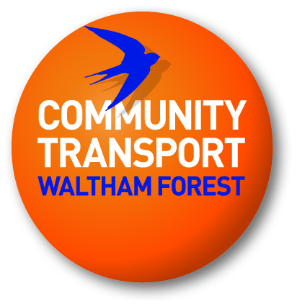
Community Driving School
Registration Form

Name: ..........................................................................................................................................

Address: .....................................................................................................................................

......................................................................................................................................................

Previous address if less than 5 years: ......................................................................................

......................................................................................................................................................

Tel: Home: ................................. Work: .......................................... Mob: ..................................

Email: ......................................................................................... DOB: .......................................

Organisation: ...............................................................................................................................

Position: ................................................... Do you hold a First Aid Certificate? Yes/No

Course attending:

Course | Duration | Tick
MiDAS Standard | Half day plus up to 1 hr driving **
MiDAS Standard and Accessible | One day plus up to 1 hr driving **
Passenger Assistant Training Scheme (PATS) | One and half days
Minibus Emergency Evacuation Procedures | Half day
Manual Handling | Half day

**PLEASE NOTE: The driving assessment will NOT take place on the day of the classroom theory session. During the classroom session, you will be given the chance to make a booking for the driving assessment at a convenient time for you and the instructor**
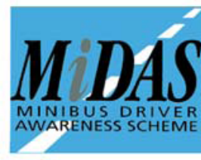


Licence and Driving Details – for MiDAS course only
Driver licence number: ........................................... Date issued: .................................
Expiry date: ............................................... Year since passed test: ............................
Current entitlements: ................................................................................ Full: Yes/No
Have you been convicted during the past 5 years of any offence in connection with a motor vehicle? Yes/No
Have you ever been disqualified from driving? Yes/No
Have you any pending prosecutions or Police enquiries for motoring offences? Yes/No
Have you had a motor insurance policy declined cancelled, refused renewal or had special conditions imposed? Yes/No
As a driver, have you been involved in an accident in the past 5 years regardless of fault? Yes/No

If yes, please provide details: ..............................................................................................................................

.............................................................................................................................................................................
Have you currently or do you have any history of any medical condition or disability which may affect your ability to drive safely now or in the future? (If in doubt, declare any condition or disability) Yes/No
Are you currently taking any medication which may affect your driving ability? Yes/No

Please return this completed form to:
Community Transport Waltham Forest
Low Hall Manor Business Park
42 Argall Avenue
Leyton
London
E107AS
info@ctwf.co.uk

Upon receipt of this registration form, we will issue a booking confirmation letter. Please note you can cancel your booking up to 3 days before the course. Cancellations after this time will not be entitled to a refund.

Please tick if you need to be issued with an invoice

If necessary, please provide a Purchase Order Number: _________________

Please tick if you will be paying by cash or cheque on the day

Please tick to confirm you have read and understood the Terms & Conditions

When returning this form, please send a photocopy of your driving licence.
On the day you MUST bring two passport photographs and your ORIGINAL driving licence (both parts) or you will not be permitted to drive the minibus – for MiDAS course only
Signed: ..................................................................................... Date: ..........................
(If electronic submission then type name)

